Ideation Phase
Brainstorm & Idea Prioritization Template

Date | 25 August 2026
Project Name | Employee Raise Issues
Maximum Marks | 4 Marks

Brainstorm & Idea Prioritization Template:
Brainstorming is a creative process that helps the team identify problems and develop effective solutions. In the Employee Raise Issues project, brainstorming is used to understand the difficulties employees face while reporting workplace issues. Team members share their ideas, discuss possible solutions, and select the most useful approach for developing the application.
Step-1: Team Gathering, Collaboration and Select the Problem Statement
Problem Statement:
Employees often face difficulties in reporting salary and workplace-related concerns through a proper and organized process. There may be delays in submitting issues, lack of proper tracking, and difficulty communicating with the concerned team.

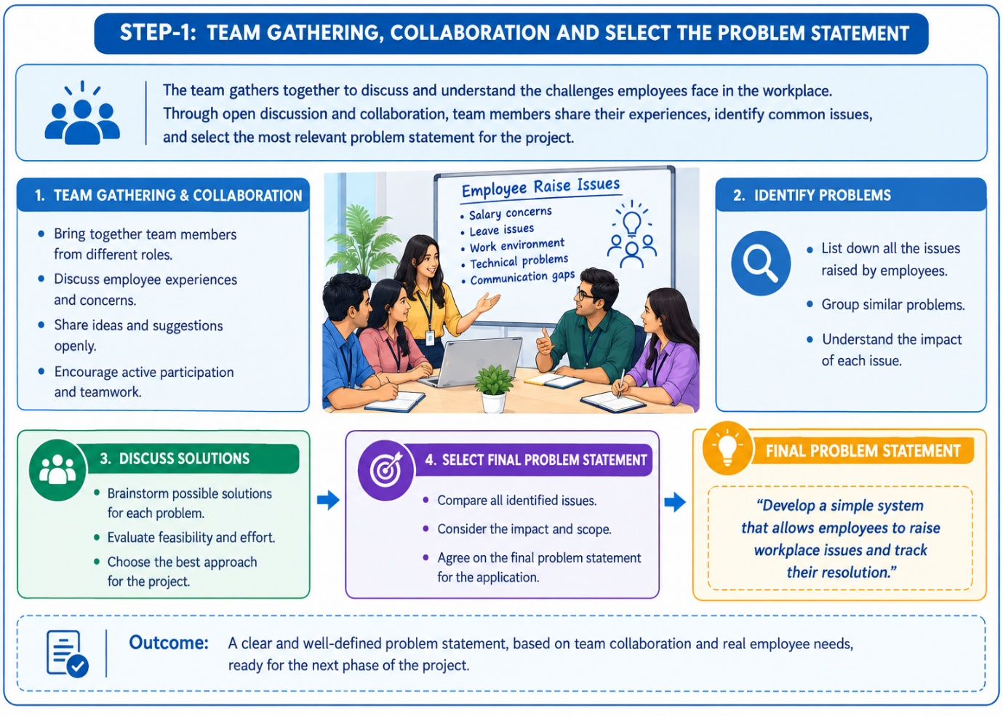

Step-2: Brainstorm, Idea Listing and Grouping
Idea listing is the process of writing down every idea generated during brainstorming in a clear and organized manner. At this stage, all ideas are recorded without judging or eliminating them. The goal is to capture every possible solution or suggestion so that no valuable idea is overlooked. Once all ideas are listed, they can be reviewed, compared, and prepared for grouping into similar categories.
Idea | Description
Improve User Experience | Make the product or service easier and more enjoyable to use.
Add New Features | Introduce new functionalities to meet customer needs.
Reduce Costs | Find ways to minimize expenses while maintaining quality.
Increase Marketing | Use digital and traditional marketing to reach more customers.
Enhance Customer Support | Provide faster and more effective assistance to customers.
Mobile-Friendly Design | Optimize the product or website for smartphones and tablets.
AI Integration | Use artificial intelligence to automate tasks and improve efficiency.
Expand to New Markets | Reach new customer groups or geographical locations.
Improve Product Quality | Enhance reliability, performance, and durability of the product.
Optimize Resources | Use available time, money, and materials more efficiently.

Grouping of Ideas:
- Marketing : Increase marketing, Expand to new markets.
- Cost & Resources : Reduce costs, Improve efficiency, Minimize waste.
- Customer Support : Enhance customer support, Faster response time.
- Product Development : Add new features, Improve product quality

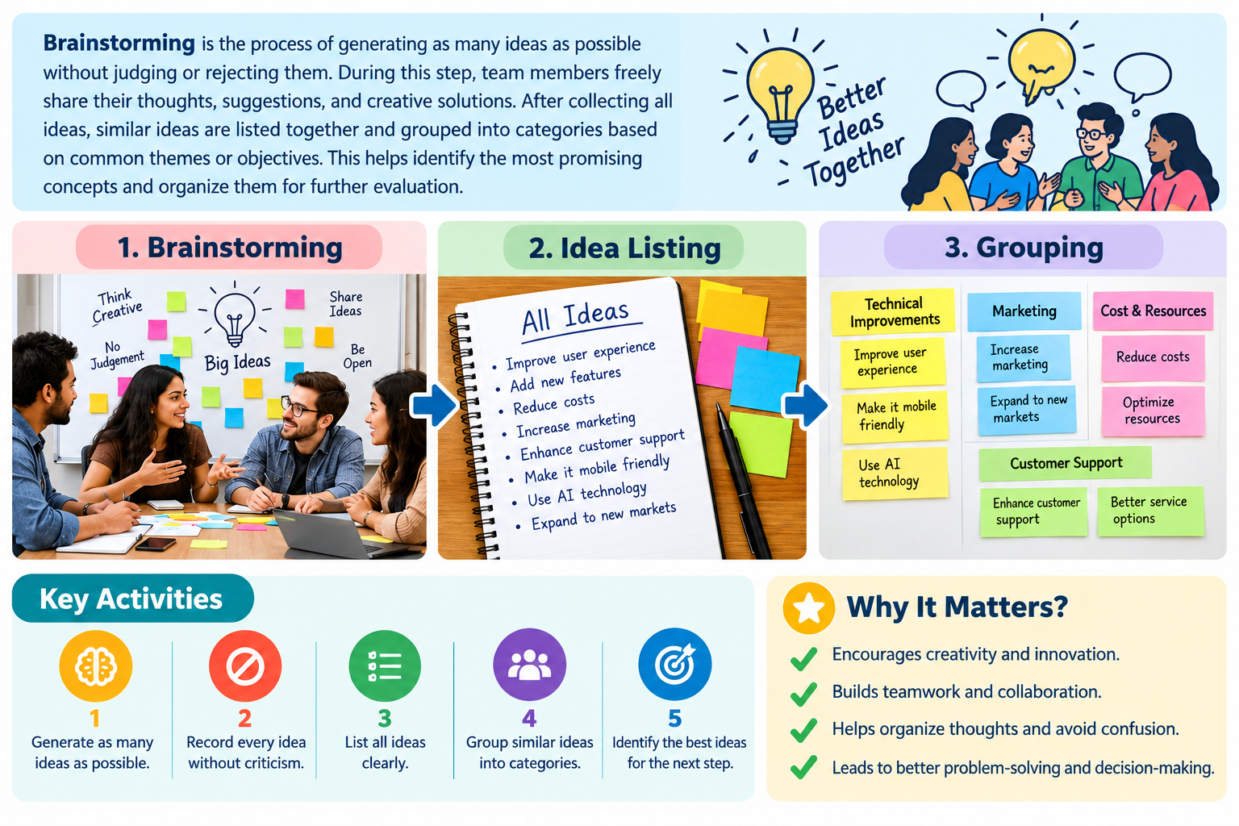
Step-3: Idea Prioritization
Idea | Priority | Reason
Improve User Experience | High | Better user satisfaction.
Mobile-Friendly Design | High | Easy mobile access.
Enhance Customer Support | High | Better customer service.
Improve Website Performance | High | Faster performance.
Add New Features | Medium | Meets user needs.
Integration AI | Medium | Improves efficiency.

